# 7. REAL ESTATE

***Real estate deals with the Real Estate Register transactions and with construction permits delivered by the Orders of Engineers in Beirut and in Tripoli***

**Real estate**

Real estate transactions are sales, donations and successions, mortagages, seizes and taxes.

**Table 7.1 – Real estate transactions in 2010**

|  |  |  |  |
| --- | --- | --- | --- |
| **Transactions. Number** | **Number** | **Peak month. %** | **Peak region. %** |
| Sales, donations and successions | 104,198 | December (10.7) | Baabda Aaley Chouf (25.0) |
| Mortgages | 17,213 | June (9.6) | Baabda Aaley Chouf (30.6) |
| Levied mortgages | 4,472 | March (10.3) | Baabda Aaley Chouf (23.9) |
| Seizes | 4,273 | June (10.5) | Baabda Aaley Chouf (23.8) |
| Levied seizes | 154 | June and August (14.1) | South-Lebanon (79.5) |
| Real estate number | 269,321 | December (10.1) | Baabda Aaley Chouf (22.1) |
| Real estate transactions and contracts | 190,422 | March (10.1) | Baabda Aaley Chouf (24.7) |
| Instead of lost | 8,487 | December (9.7) | Baabda Aaley Chouf (23.2) |
| **Real-estate court transactions. Number** | **41,779** | **Peak month. %** | |
| Real estate number | 22,875 | December (11.3) | |
| Transactions and contracts | 15,770 | December (11.6) | |
| Sales, donations, and successions | 2,946 | March (10.9) | |
| Real-estate mortgages | 117 | September (17.1) | |
| Levied mortgages | 32 | October (25.0) | |
| Levied seizes | 23 | September (21.7) | |
| Seizes | 16 | May (43.8) | |
| **Transactions. Value** | **Million LBP** | **Peak month. %** | **Peak region. %** |
| Sales, donations and successions | 14,174,586 | December (12.5) | Beirut (27.3) |
| Mortgages | 6,987,558 | July (13.4) | Baabda Aaley Chouf (29.6) |
| Levied mortgages | 1,175,156 | November (11.4) | Beirut (26.0) |
| Main taxes | 915,557 | December (11.3) | Beirut (29.4) |
| Taxes paid by foreigners | 53,859 | December (19.5) | Beirut (55.2) |
| Received taxes in sale contracts | 759,092 | December (11.0) | Beirut (28.7) |
| Received municipal tax | 218,043 | December (11.4) | Beirut (30.3) |
| **Real-estate court transactions. Value** | **138,955** | **Peak month. %** | |
| Sales, donations & successions | 115,643 | September (25.2) | |
| Real-estate mortgages | 8,375 | January (23.6) | |
| Main taxes | 8,117 | September (22.9) | |
| Received taxes in sale contracts | 6,820 | September (23.7) | |
| Levied mortgages | 1,926 | March (32.1) | |
| Received municipal tax | 74 | August (21.6) | |
| Taxes paid by foreigners | 21 | February and October (14.3) | |

*Table made by CAS based on Real-estate services of cazas data (2010)*

The figures show that Beirut comes first when it comes to monetary values except for mortagages (Baabda Aaley Chouf).

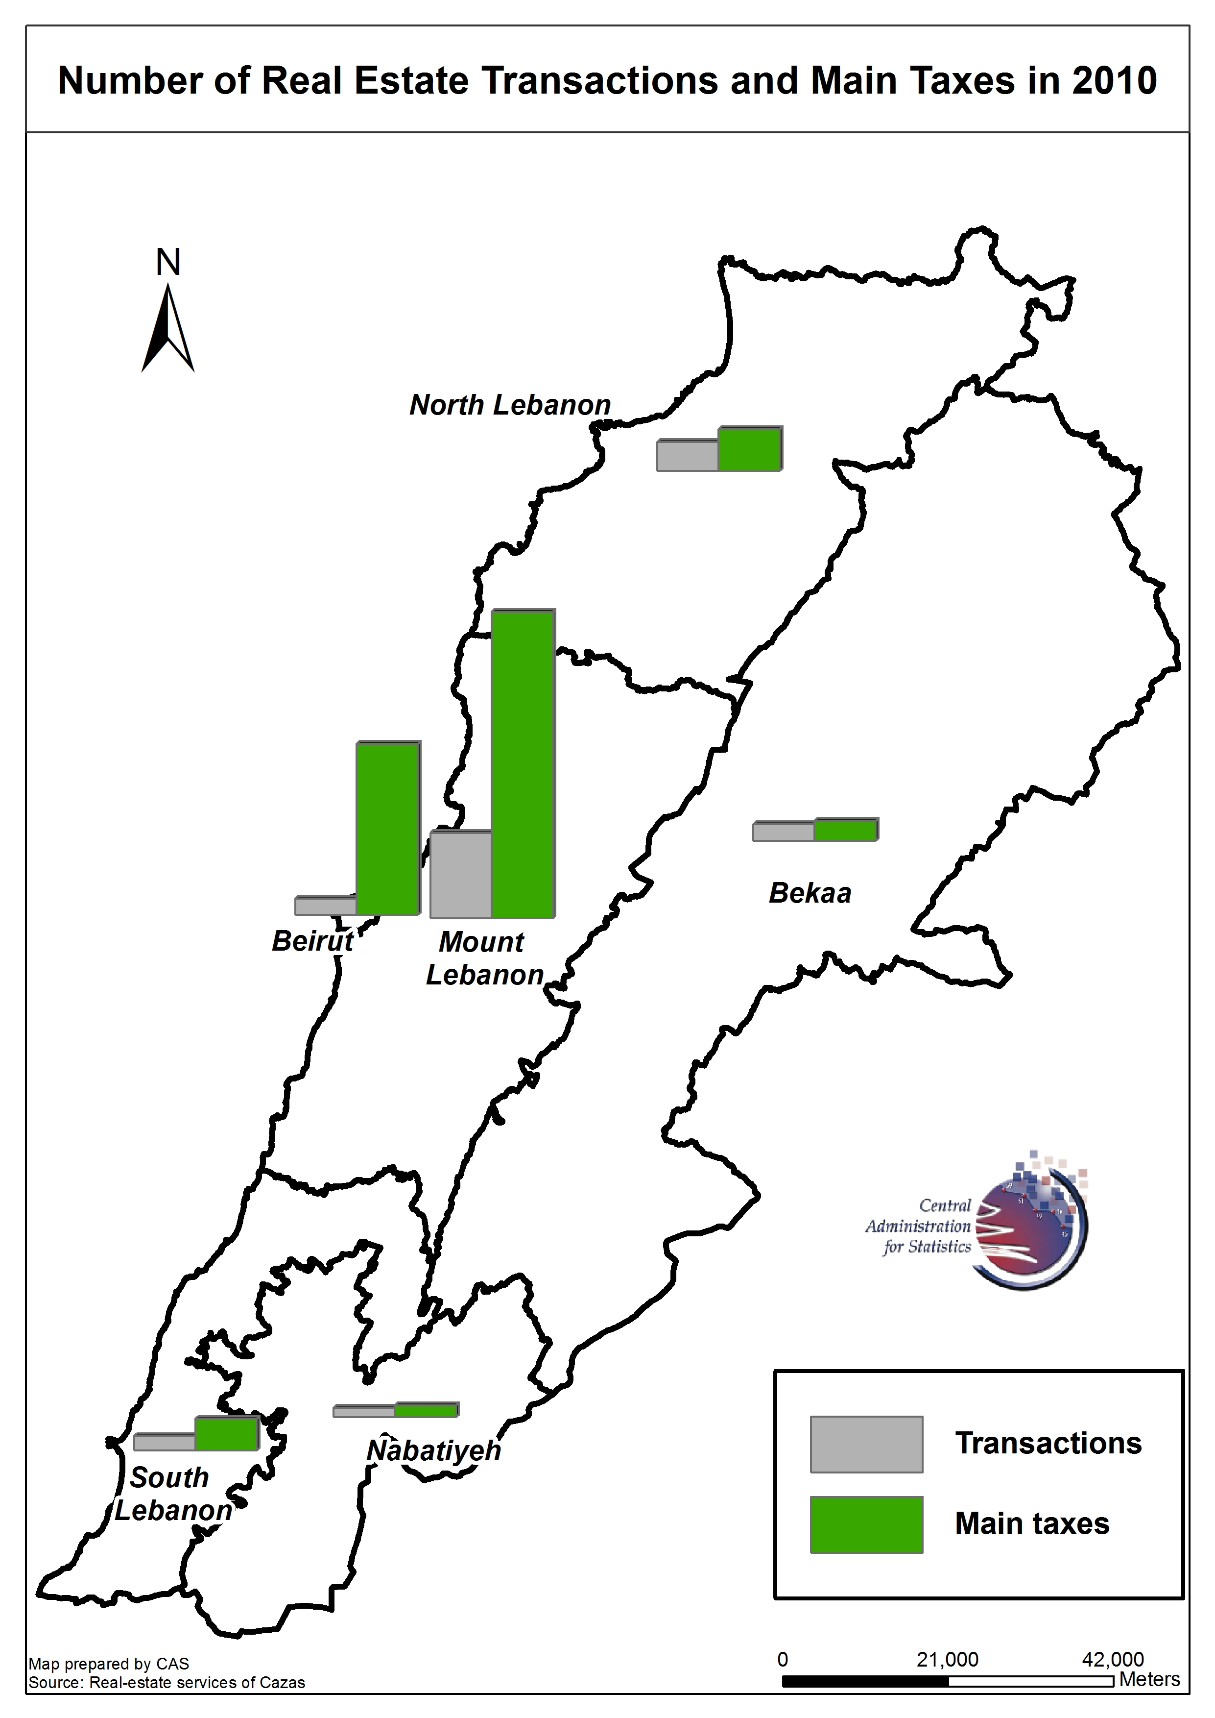

**Construction permits**

The Ordre des Ingénieurs et des Architectes de Beyrouth and the Order of Engineers and Architects of Tripoli allowed the construction over 17,625 thousand square meters through 17,018 transactions.

**Table 7.2 – Orders of Engineers in 2010**

|  |  |  |
| --- | --- | --- |
| **Type** | **Ordre des Ingénieurs et des Architectes de Beyrouth** | **Order of Engineers and Architects of Tripoli** |
| **Total area = 17,625 thousand square meters** | | |
| Area. Thousand square meters | 15,187 | 2,438 |
| Area. % | 86.2 | 13.8 |
| Area Peaks. Thousand square meters | 9,614 | 1,834 |
| Area Peaks. % | 63.6 | 75.2 |
| **Total transactions = 17,018** | | |
| Transactions. Number | 15,641 | 1,377 |
| Transactions. % | 91.9 | 8.1 |

*Table made by CAS based on Ordre des Ingénieurs et des Architectes de Beyrouth and the Order of Engineers and Architects of Tripoli data (2010)*

**Graph 7.1 – Construction permits registered at the Ordre des Ingénieurs et des Architectes de Beyrouth (1996-2010). Thousand square meters**



*Graph made by CAS based on* ***Ordre des Ingénieurs et des Architectes de Beyrouth*** *data (1996-2010)*