20. HEALTH

Health deals with private hospitals statistics, Ministry of Public Health (MOPH) subsidized hospital admissions, HIV/AIDS, immunization, disease cases reported to MOPH, morbidity indicators, and MOPH budget.

Health in 2010:
- Total hospitals: 162.
  - Private hospitals: 85.2% of total hospitals.
  - Public hospitals: 14.8% of total hospitals.
- Admissions in hospitals: 229,529 admissions.
  - Private hospitals: 70.8% of total admissions.
  - Public hospitals: 29.2% of total admissions.
- HIV/AIDS incidence in Lebanon:
  - Till November 2010: 1,271 cases.
- Routine immunization coverage rates by caza:
  - OPV3: 94.0%.
  - Population hospitalized among eligible population by Caza: 8.0%.
  - Breast cancer out of total female neoplasm by Caza: 38.3%.
- Notifiable disease cases reported to MOPH:
  - Vaccine preventable diseases: 345 cases.
  - Food and water borne diseases: 1,967 cases.
  - Other diseases: 403 cases.
- Most reported morbidity indicators:
  - Malaria: 66 cases.
  - Measles: 11 cases.
  - AIDS: 21 cases.
  - MOPH total budget: 486,658,209,000 LBP.

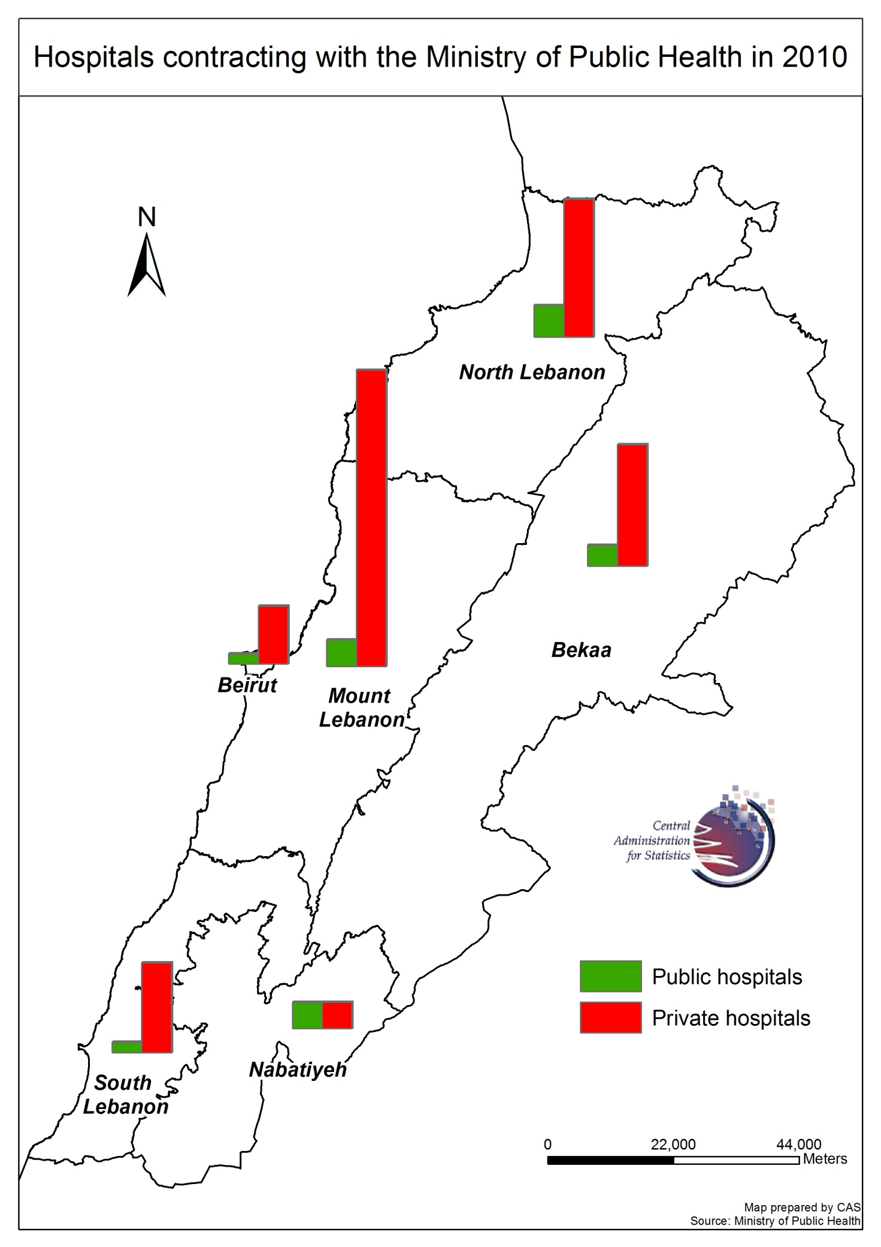

MOPH Subsidized hospitals admissions

There are 229,529 hospitalized diagnoses in 2010.
MOPH subsidized hospitals admissions in 2010: 267,860:

Category of diagnosis and sex
Among the 267,860 hospitalized cases, 55.2% are females.

Table 20.1 – Categories of diagnosis and sex in 2010
Code | Description | Number | % of total admissions | Females. % of description | Peak disease. % of description
A00-B99 | Certain infections and parasitic diseases | 11,292 | 4.2 | 46.9 | A00-A09 – Intestinal infectious diseases (90.5)
C00-D48 | Neoplasm | 25,803 | 9.6 | 59.1 | C00-C97 – Malignant neoplasms (88.3)
D50-D53 | Diseases of the blood and blood forming organs and certain disorders involving the immune mechanism | 3,298 | 1.2 | 53.2 | D60-D64 – Aplastic and other anaemias (41.8)
E00-E90 | Endocrine, nutritional and metabolic diseases | 5,511 | 2.1 | 63.2 | E10-E14 – Diabetes mellitus (60.4)
F00-F99 | Mental and behavioral disorders | 1,647 | 0.6 | 41.8 | F20-F29 – Schizophrenia, schizotypal and delusional disorders (54.9)
G00-G99 | Diseases of the nervous system | 4,298 | 1.6 | 50.5 | G40-G47 – Episodic and paroxysmal disorders (37.6)
H00-H59 | Diseases of the eye and adnexa | 8,001 | 3.0 | 54.3 | H25-H28 – Disorders of lens (76.4)
H60-H95 | Diseases of the ear and mastoid process | 1,572 | 0.6 | 49.7 | H65-H75 – Diseases of middle ear and mastoid (63.5)
I00-I99 | Diseases of the circulatory system | 37,476 | 14.0 | 46.8 | I20-I25 – Ischaemic heart diseases (47.6)
J00-J99 | Diseases of the respiratory system | 27,834 | 10.4 | 46.4 | J09-J18 – Influenza and pneumonia (36.1)
K00-K93 | Diseases of the digestive system | 21,638 | 8.1 | 47.7 | K40-K46 – Hernia (25.6)
L00-L99 | Diseases of the skin and subcutaneous tissue | 1,840 | 0.7 | 41.8 | L00-L08 – Infections of the skin and subcutaneous tissue (66.3)
M00-M99 | Diseases of the musculoskeletal system and connective tissue | 8,457 | 3.2 | 58.1 | M00-M25 – Arthropathies (38.3)
N00-N99 | Diseases of the genitourinary system | 21,902 | 8.2 | 55.3 | N20-N23 – Urolithiasis (33.0)
O00-O99 | Pregnancy, childbirth and the puerperium | 24,350 | 9.1 | 100.0 | O80-O84 – Delivery (91.3)
P00-P96 | Certain conditions originating in the perinatal period | 3,652 | 1.4 | 41.6 | P20-P29 – Respiratory and cardiovascular disorders specific to the perinatal period (52.2)
Q00-Q99 | Congenital malformations, deformations and chromosomal abnormalities | 1,565 | 0.6 | 32.7 | Q50-Q56 – Congenital malformations of genital organs (32.3)
R00-R99 | Symptoms, signs and abnormal clinical and laboratory findings, not elsewhere classified | 41,203 | 15.4 | 54.5 | R10-R19 – Symptoms and signs involving the digestive system and abdomen (42.8)
S00-T98 | Injury, poisoning and certain other consequences of external causes | 14,119 | 5.3 | 38.4 | T00-T07 – Injuries involving multiple body regions (14.1)
V01-Y98 | External causes of morbidity and mortality | 162 | 0.1 | 32.1
Z00-Z99 | Factors influencing health status and contact with health services | 2,240 | 0.8 | 53.0 | Z40-Z54 – Persons encountering health services for specific procedures and health care (62.1)
Total |  | 267,860 | 100.0 | 55.2
Table made by CAS based on Ministry of Public Health data (2010)

Peak of category of diagnosis:
- R00-R99 - Symptoms, signs and abnormal clinical and laboratory findings, not elsewhere classified: 15.4%.

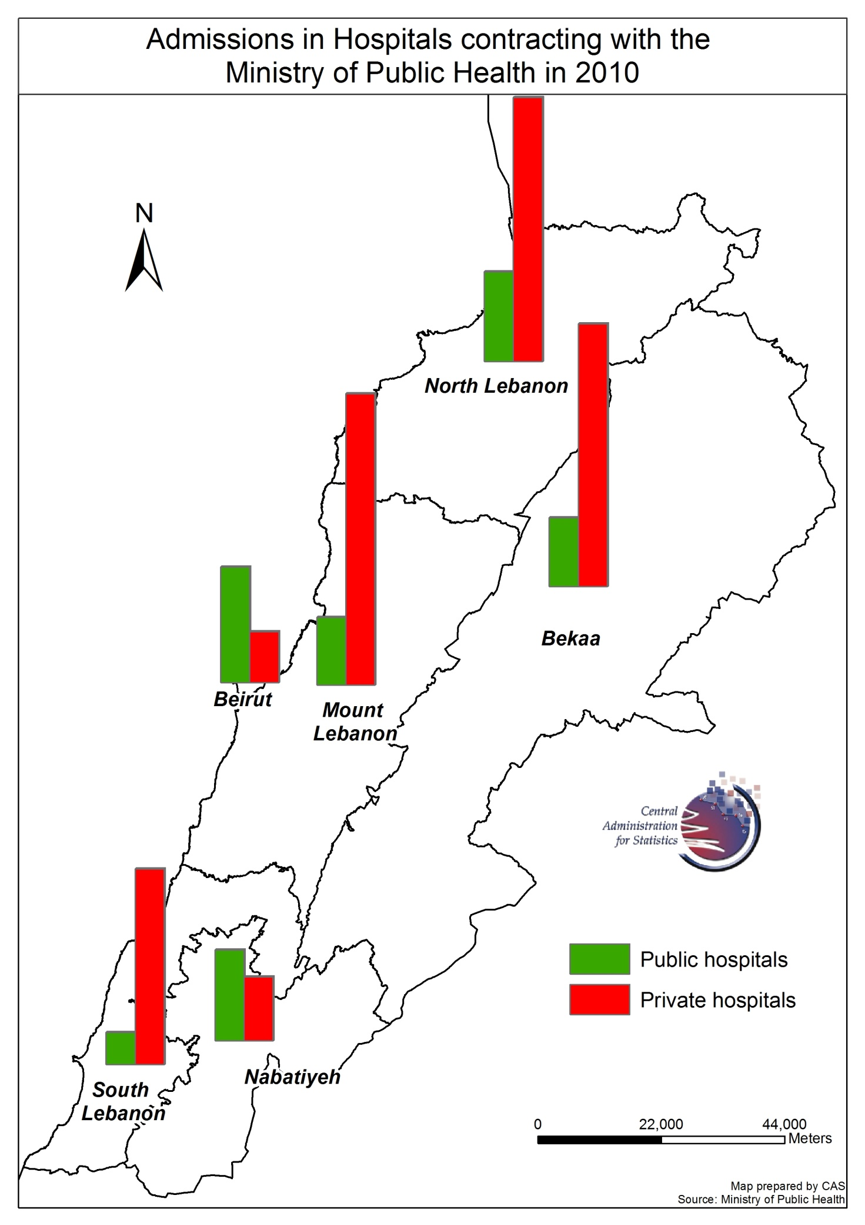

HIV / AIDS

21 cases of HIV / AIDS are reported in 2010 and 1,271 cases till Novmeber 2010 in Lebanon.

Table 20.2 – HIV / AIDS
Reported cases till November 2010
Stage of the disease
HIV | 42.0%
AIDS | 23.0%
Not specified | 23.0%
Sex
Females | 11.0%
Males | 89.0%
Age group
< 30 | 18.0%
31 - 50 | 30.0%
> 51 | 17.0%
Not specified | 35.0%
Mode of transmission
Sexual | 76.3%
Unspecified / Missing | 23.5%
Sexual behavior
Homosexual | 19.4%
Bisexual | 16.1%
Heterosexual | 20.4%
Not specified | 44.0%
Recent travel history
Yes | 29.0%
No | 71.0%
Total cases | 1,271
Table made by CAS based on Ministry of Public Health data (2010)

Notifiable disease cases reported to MOPH

In 2010, there are three types of notifiable diseases cases.

Table 20.3 – Notifiable disease cases
Category | Cases | Peak disease. % of total cases | Peak month. % of total cases
Vaccine preventable diseases | 345 | Viral hepatitis B (70.7) | April (11.3)
Food and water borne diseases | 1,967 | Typhoid fever (29.1) | August (19.6%)
Other diseases | 403 | Meningits (45.3) | April (11.7)
Table made by CAS based on Ministry of Public Health data (2010)

Reported cases by age and sex
In 2010, there are three types of notifiable diseases cases.

Table 20.4 – Notifiable disease cases by age and sex
Category | Cases | Peak age. % of total cases | Females. % of total cases
Vaccine preventable diseases | 345 | 20-39 years (32.8) | 34.2
Food and water borne diseases | 1,967 | 20-39 years (26.6) | 48.2
Other diseases | 403 | 20-39 years (24.3) | 35.2
Table made by CAS based on Ministry of Public Health data (2010)

Reported cases by Mohafzat
In 2010, there are three types of notifiable diseases cases.

Table 20.4 – Notifiable disease cases by age and sex
Category | Cases | Peak Mohafzat. % of total cases
Vaccine preventable diseases | 475 | Mount- Lebanon (29.0)
Food and water borne diseases | 2,174 | Mount-Lebanon (40.5)
Other diseases | 391 | Mount-Lebanon (32.3)
Table made by CAS based on Ministry of Public Health data (2010)

Selected morbidity indicators

MOPH takes into account five morbidity indicators for the period 2004-2010.

Table 20.5 – Selected morbidity indicators
Indicator | Cases in 2004 | Cases in 2010 | Change between 2004-2010. %
Malaria | 68 | 66 | (2.9)
Measles | 261 | 11 | (95.8)
AIDS | 23 | 21 | (8.7)
Tetanus | 1 | 2 | 100.0
Table made by CAS based on Ministry of Public Health data (2010)

MOPH itemized budget

MOPH itemized budget is studied for the period 2005-2010.

Table 20.6 – MOPH itemized budget. 1,000 LBP
Item | 2005 | 2006 | 2007 | 2008 | 2009 | 2010 | Change between 2005-2010. %
Hospitalization in private sector | 241,357 | 238,875,000 | 25,000,000 | 256,000,000 | 305,000,000 | 320,000,000 | 132,484
Publics hospitals | 20,000,000 | 12,054,000 | 15,000,000 | 15,000,000 | 12,000,000 | 12,000,000 | (40)
Drugs | 44,880,000 | 48,000,000 | 50,000,000 | 52,500,000 | 66,000,000 | 91,000,000 | 103
Contributions to NGOs | 10,893,000 | 13,417,770 | 12,617,770 | 12,817,770 | 12,817,770 | 12,817,770 | 18
Salaries and other employees' benefits | 24,730,000 | 24,535,092 | 24,173,000 | 24,052,860 | 27,522,100 | 27,472,900 | 11
Other expenses | 8,644,000 | 9,189,638 | 7,950,800 | 11,047,403 | 13,936,228 | 18,593,039 | 115
Central laboratory (part 1) | 1,198,000 | 1,145,500 | 990,100 | 992,192 | 948,500 | 977,500 | (18)
Part Two (Central laboratory and MOPH) | 8,598,000 | 1,572,000 | 900,000 | 1,507,000 | 1,523,000 | 3,797,000 | (56)
Total budget of MOPH | 360,300,000 | 348,789,000 | 361,631,670 | 373,917,225 | 439,747,598 | 486,658,209 | 35
Total government budget | 10,000,000 | 11,195,000,000 | 11,840,000,000 | 11,475,000,000 | 16,304,000,000 | 19,537,600,000 | 195,276
Government debt | 3,900,000,000 | 4,653,000,000 | 4,900,000,000 | 4,650,000,000 | 6,441,000,000 | 6,860,120,314 | 76
Total government budget excluding debts | 6,100,000,000 | 6,542,000,000 | 6,940,000,000 | 6,825,000,000 | 9,863,000,000 | 12,677,479,686 | 108
Ministry of Public Health Budget out of total government budget (with debt). % | 3.60 | 3.12 | 3.05 | 3.26 | 2.70 | 2.49
Ministry of Public Health Budget out of total government budget (without debt). % | 5.91 | 5.33 | 5.21 | 5.48 | 4.46 | 3.84
Table made by CAS based on Ministry of Public Health data (2010)

The most obvious characteristics of this table are the following:
- Hospitalization in private sector increased 132,484 % between 2005 and 2010.
- Public hospitals budget decreased 40% between 2005 and 2010.
- Drugs increased 103% between 2005 and 2010.
- Other expenses increased 115% between 2005 and 2010.
- Part Two (Central Laboratory and MOPH) decreased 56% between 2005 and 2010.
- MOPH total budget increased 35% between 2005 and 2010.

