12. SEA TRANSPORT

Sea transport deals with all ports statistics and mainly with those of the Compagnie de Gestion et d'Exploitation du Port de Beyrouth.

Six ports provide CAS with figures: Beirut, Tripoli, Tyr, Saida, Jieh and Zahrani, and Jounieh.

Table 12.1 – Ports of Lebanon. Traffic in 2010
Port | Incoming ships. Number | Incoming ships capacity. Tonnes | Unloaded petroleum. Tonnes | Unloaded cargo. Tonnes | Loaded cargo. Tonnes | Imported cars and vehicles. Number
Beirut | 2,161 | 326,888 | 90,955 | 5,560,649 | 820,751 | 95,047
Peak. % | May (9.7) | May (9.7) | January (17.0) | May (10.2) | May (10.6) | July (11.2)
Tripoli | 515 | 1,135,325 | 1,032,957 | 1,026,242 | 226,315 | 20,422
Peak. % | July (10.7) | November (10.1) | January (16.2) | December (11.8) | April (18.4) | July (19.4)
Tyr | 14 | 40098 |  | 7,004 |  | 4,839
Peak (%) | April, June, September, and November (14.3) | November (14.4) |  | April (14.5) |  | April (14.4)
Saida | 96 | 108,748 | 14,356 | 131,385 | 33,405 | 6,619
Peak. % | July (13.5) | July (13.8) | February (25.5) | May (13.8) | July (15.8) | March (19.8)
Jieh and Zahrani | 36 | 105,177 | 1,765,670 | 293,810 | 0
Peak. % | April (19.4) | June (20.5) | September (13.0) | June (22.4) | 0
Jounieh | 40 |  | 907,911
Peak. % | August and September (12.5) |  | September (12.4)
Total | 2,862 | 1,716,236 | 3,811,849 | 7,019,090 | 1,080,471 | 126,927
Peak port. % | Port of Beirut (75.5) | Port of Tripoli (66.2) | Port of Jounieh (46.3) | Port of Beirut (79.2) | Port of Beirut (76.0) | Port of Beirut (74.9)
Table made by CAS based on General Directorate for Transport data (2010)

Lebanon foreign trade in gross quantities in 2010:
- General imports: 16,630,057 thousand tonnes of which 0.04% are imported through the ports of Lebanon.
- General exports: 3,672,230 thousand tonnes of which 0.03% are exported through the ports of Lebanon.

Lebanon total imports of petroleum products in 2010: 9,994,891 tonnes of which:
- MEW imports: 36.7% of total imports of petroleum products.
- Others imports: 54.4% of total imports of petroleum products.
- Refineries of Tripoli and Zahrani: 8.9% of total imports of petroleum products.
- Total unloaded petroleum in all the ports of Lebanon: 3,811,849 tonnes (38.1% of total imports of petroleum products).
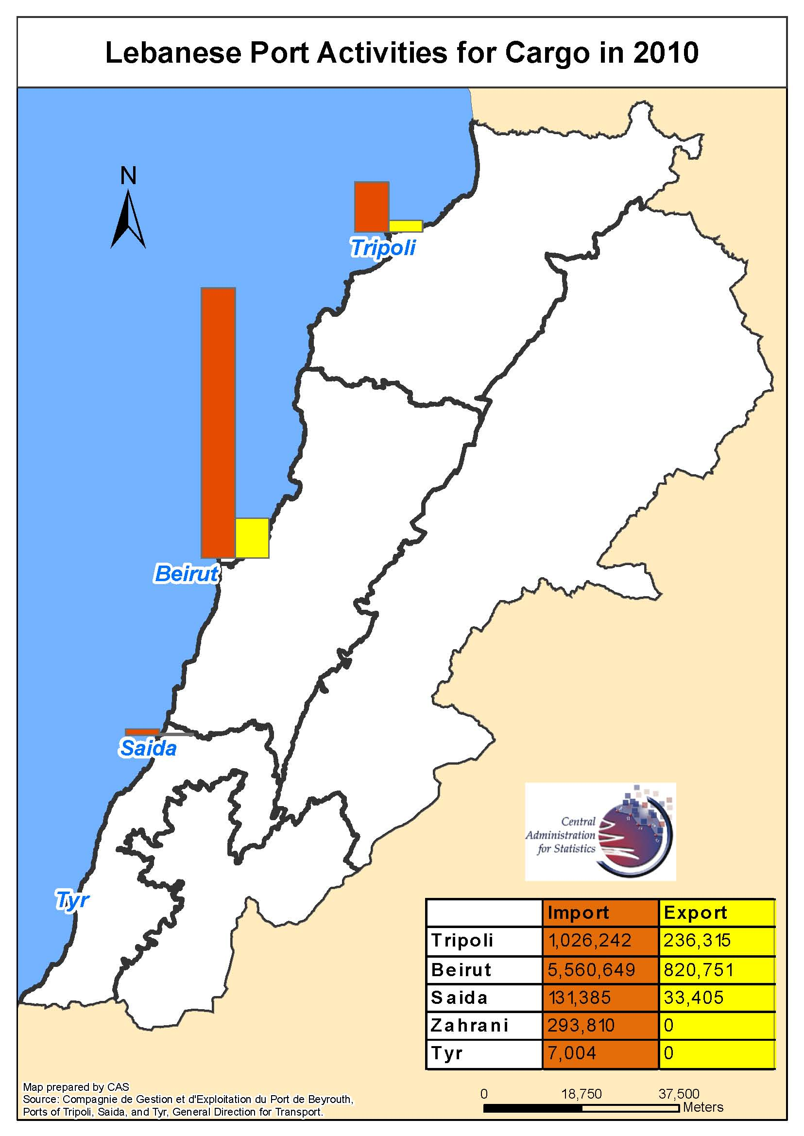

Port of Beirut

The Port of Beirut is the major port in Lebanon. It receives cargo and passengers. Besides it has its own traffic and financial results.
Port of Beirut activity is as follows in 2010:
- Average per day: 75 incoming boats.
- Imported and exported cargo: 6,470,000 tonnes.
- Total Equivalent Units (TEU) for containers + transshipment (TS): 949,101.
- Total port revenues: 166,833,999 USD.

Table 12.2 – Port of Beirut. Activity in 2010
Item | Number | Peak month | Peak month. %
Boats. Number | 2,285 | May (223) | May (9.8)
Engine ships | 2,161 | May (210) | May (9.7)
Sailing boats | 3 | March (2) | March (66.7)
Tankers | 123 | September (14) | September (11.4)
Goods imported and exported. 1,000 tonnes | 6,324 | August (594) | August (9.4)
Total port revenues. USD | 166,833,999 | June (15,538,220) | June (9.3)
Disembarked tourists. Number | 7,121 | October (1,673) | October (23.5)
Transit traffic. Tonnes | 39,271 | March (4,270) | March (10.8)
Unloaded cargo by containers. Tonnes | 3,280,107 | July (329,862) | July (10.1)
Loaded cargo by containers. Tonnes | 500,312 | October (52,016) | October (10.4)
Imported cars. Number | 95,047 | July (10,657) | July (11.2)
Unloaded cargo. Tonnes | 2,364,919 | May (287,594) | May (12.2)
Loaded cargo. Tonnes | 320,441 | May (40,728) | May (12.7)
Unloaded petroleum. Tonnes | 90,955 | January (15,433) | January (17.0)
Unloaded living stock. Number | 313,423 | November (56,496) | November (18.0)
Table made by CAS based on Compagnie de Gestion et d'Exploitation du Port de Beyrouth data (2010)

The cargo movement in Port of Beirut is summarized in the following tables regarding loaded and unloaded cargo.

Table 12.3 – Port of Beirut. Top 2 unloaded cargos in 2010
Unloaded cargo | Number | % | Peak month. Tonnes | Peak month. %
By piece
By piece | 406,823 | 100.0 | November (63,517) | November (15.6)
Living stock | 313,423 | 77.0 | November (56,496) | November (18.0)
Cars and accessories | 93,395 | 23.0 | July (10,637) | July (11.4)
Ordinary cargo. Tonnes
Ordinary cargo | 2,364,919 | 100.0 | May (287,594) | May (12.2)
Iron, Copper, and their products | 538,368 | 22.8 | January (76,213) | January (14.2)
Wheat | 372,292 | 15.7 | October (84,518) | October (22.7)
Container cargo. Tonnes
Container cargo | 3,280,107 | 100.0 | July (329,862) | July (10.1)
Other cargo | 1,605,626 | 49.0 | June (154,073) | June (9.6)
Construction material | 357,441 | 10.9 | July (43,473) | July (12.2)
Total unloaded cargo. Tonnes
Total cargo | 5,652,619 | 100.0 | May (571,095) | May (10.1)
Other cargo | 1,644,714 | 29.1 | June (156,679) | June (9.5)
Iron, Copper, and their products | 539,759 | 9.5 | January (76,221) | January (14.1)
Table made by CAS based on Compagnie de Gestion et d'Exploitation du Port de Beyrouth data (2010)

Table 12.4 – Port of Beirut. Top 2 loaded cargos in 2010
Loaded cargo | Number | % | Peak month. Tonnes | Peak month. %
By piece
By piece | 482,125 | 100.0 | September (54,436) | September (11.6)
Living stock | 8,524 | 1.8 | January (8,500) | January (99.7)
Cars and accessories | 1,652 | 0.3 | February (575) | February (34.8)
Ordinary cargo. Tonnes
Ordinary cargo | 320,441 | 100.0 | May (40,728) | May (12.7)
Iron minerals | 269,387 | 84.1 | March (38,432) | March (14.3)
Wheat | 21,624 | 6.7 |  | August (34.1)
Container cargo. Tonnes
Container cargo | 500,312 | 100.0 | October (52,016) | October (10.4)
Other cargo | 334,370 | 66.8 | October (40,444) | October (12.1)
Clothes | 35,057 | 7.0 | March (33,503) | March (95.6)
Total unloaded cargo. Tonnes
Total cargo | 820,753 | 100.0 | May (86,869) | May (10.6)
Other cargo | 343,330 | 41.8 | October (41,043) | October (12.0)
Iron minerals | 298,446 | 36.4 | March (40,684) | March (13.6)
Table made by CAS based on Compagnie de Gestion et d'Exploitation du Port de Beyrouth data (2010)

